**GDSD Team 4 WS 2023/2024 Milestone 2:**

**More detailed specs, tools, servers and architecture defined, UI mock-ups, first vertical prototype**

Global Software Development

WWW site for Buy/Sell/Share of Digital media

Project: ArtSync Fulda

Team 4: The Binary Bunch (local)

**Submission on 01.12.2023 by:**

Jonas Wagner (JW)

jonas.wagner@informatik.hs-fulda.de

Team Lead

Dipesh Kewalramani (DK)

dipesh.kewalramani@informatik.hs-fulda.de

Frontend Lead

Seshenya Weerasinghe (SW)

seshenya.weerasinghe@informatik.hs-fulda.de

Backend Lead

Gihan Kaushal Weerappullige (GK)

gihan-kaushal.weerappullige@informatik.hs-fulda.de

GitHub Master

Rohan Kolagada (RK)

rohan.kolagada@informatik.hs-fulda.de

Developer

Alex Francis Pullukkara (AF)

alex-francis.pullukkara@informatik.hs-fulda.de

Developer

Prof. Dr. Rainer Todtenhöfer

Class CEO/CTO

| **Revision** | **Submission Date** | **Author(s)** | **Description** |
| --- | --- | --- | --- |
| Milestone 2 DRAFT | 26.11.2023 | JW, DK, SW, GK, RK, AF | Draft version of Milestone 2 |
| Milestone 2 | 01.12.2023 | JW, DK, SW, GK, RK, AF | Final version of Milestone 2 |
|  |  |  |  |

**Table of contents**

1. Functional Requirements - prioritized 3
2. List of main data items and entities 6
3. UI Mockups and Storyboard 8
4. High Level Architecture, Database Organization 11
5. High Level UML Diagrams 14
6. Identify actual key risks for your project at this time 17
7. Project Management 20

**1. Functional Requirements - prioritized**

**1.1 Priority 01 functional requirements**

**1. User Registration and Login as a Buyer/ Seller/Administrator**

Registration form for users to input basic details like name, email, and password. Clear interface facilitating a smooth onboarding process. Email verification process to ensure the security and authenticity of user registrations.

**3. Edit user profile**

Easy-to-navigate profile management interface, allowing users to update information.

**4. Media content approval**

Admin interface for reviewing and approving/disapproving seller-uploaded media content to maintain quality standards.

**5. Seller media upload**

Seller-friendly interface for seamless digital media upload. Sellers can input product details, including name, description, and price, and select the media category to enhance the organisation and visibility of their products for potential buyers.

**6. Edit product details**

Interface for updating product details which allows quick edits to information like product price, descriptions and other specifications.

**7. Buyer product purchase**

User-friendly buyer interface displaying essential details of products like name, price, and a brief description to purchase digital media products.

**8. Product Search functionality**

A simple search bar on the buyer interface lets users to find digital media products by typing keywords. This feature streamlines the shopping experience, allowing buyers to discover specific items, such as images or videos, quickly and precisely according to their interests or preferences.

**9. Media categorization**

Buyer interface with categories for easy sorting. Buyers can quickly filter and find digital media products, making it straightforward to discover and purchase items.

**10. Chat feature**

Communication tool for sellers and buyers after placing an order. Allows direct chatting to discuss updates, and clarify details related to the purchase.

**11. Order history view**

User interface that provides visibility into past and current orders. Allows users to easily track and review their order history for a comprehensive overview of their digital media purchases.

**12. Selling item count**

Display functionality indicating the number of units sold for each digital media product. This Offers sellers valuable insights about the popularity and demand for their products.

**13. Product rating**

Users can rate digital media products using stars to show their overall satisfaction.

**14. Product Reviews**

Buyers can provide detailed feedback by writing reviews and sharing their specific experiences and opinions.

**15. Download Management**

This functionality ensures a secure and user-friendly digital media download experience

**16. Content Browsing**

Allow users to explore digital media content without the need for registration.

Implement a user-friendly interface with filters and sorting options for easy content discovery.

**1.2 Priority 02 functional requirements**

**1. Collaboration management**

Interface for managing collaboration requests, accepting or rejecting requests, and coordinating with collaborators.

**2. Competition/Challenge creation**

Interface for creating a new competition or challenge. Form fields for detailed information such as competition name, description, rules, submission guidelines, deadline, and any other relevant details.

**3. Participant Registration for Competition**

An interface that showcases the list of available competitions and allows participants to easily register for their chosen competition and automatic confirmation to participants upon successful registration.

**4. Ban User by Admin**

Implement an administrative feature allowing authorized personnel to ban users when necessary. This functionality provides a straightforward interface for administrators to manage user access.

**5. Shopping cart functionality**

A user-friendly feature allowing buyers to add preferred digital media items to their cart. Buyers can easily view and manage all selected items in the cart for a convenient and organized shopping experience.

**2. List of main data items and entities**

1. User

* Username
* Email
* Password
* Contact information
* Skills

Users can create their profiles to embark on a personalized journey through digital media and connect with a community of individuals working with digital content. There are two types of users: Generic User and Admin User.

1. Digital Media

* Title
* Description
* Price
* File format
* Size
* Resolution
* Date

Users add digital media items with titles, descriptions, and optional pricing to the platform, populating it with a variety of content. Users create listings, adding metadata such as type, tags, and categories to make digital media discovery and categorization easier.

1. Message

* Sender
* Receiver

Easily communicate between users using our messaging system. Negotiation on products via messages contribute to an improved user experience.

1. Events

* Title
* Digital content
* Date

Users add university events with the content they want to publish on the platform. This content exists on the website for until the deadline concludes.

1. Competitions

* Title
* Description
* Deadline
* Rules
* Winners

Users have the opportunity to host competitions on the platform, inviting fellow users to contribute their related digital media. Winners are determined upon reaching the competition deadline.

1. Collaborations

* Title
* Description
* Members
* Owner

Users collaborate on the platform according to their interests and skills. Collaborative projects are showcased on the platform, and any user can request to join. Acceptance of the request is contingent upon how well the user's skills align with the requirements of the collaborated project.

**3. UI Mockups and Storyboard**

The task at hand involves crafting high-level UI mockups and storyboards for several pivotal use cases outlined in the project's scope. These mockups, roughly 4-5 major use cases, are envisioned to encapsulate 1-3 screens per use case. The primary focus lies in creating wire diagrams initially, emphasizing fundamental layout structures and succinctly describing the functionalities within each key section of the graphical user interface (GUI). These diagrams will evolve into simple yet coherent "storyboards", arranged according to use cases, enabling a seamless assessment of navigation and user flow.

As team we had a meeting to gather all possible pages in our application: Login, Registration/Sign Up, Home Page, Explore Page, Search Page Items, Profile Page, Sell Page, Sell new Item, Admin Dashboard, Details Product Item, Competition Page, Details Competition Page, Create Competition, My Competitions Page, Evaluate Competition, Message Page, Shared Media Page, Shopping Cart, Checkout Page, Order History Page, Collaboration Page, My Collaboration Page, Detail Collaboration Project

**Some Example UI Mockups:**

Home Page:

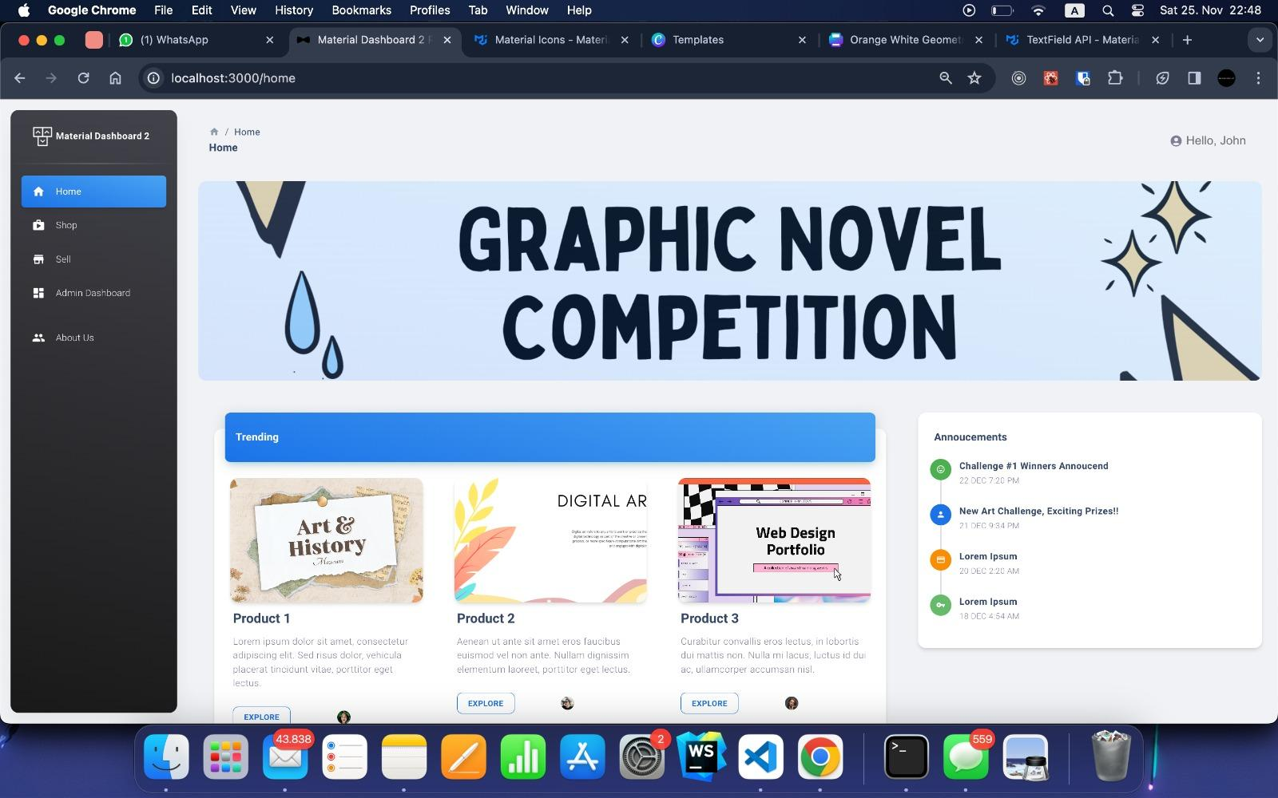

Profile:

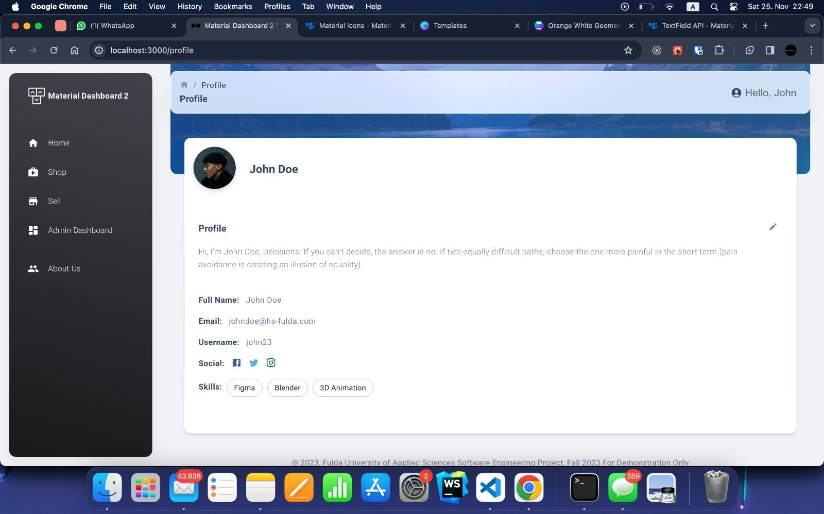

Buy Page:

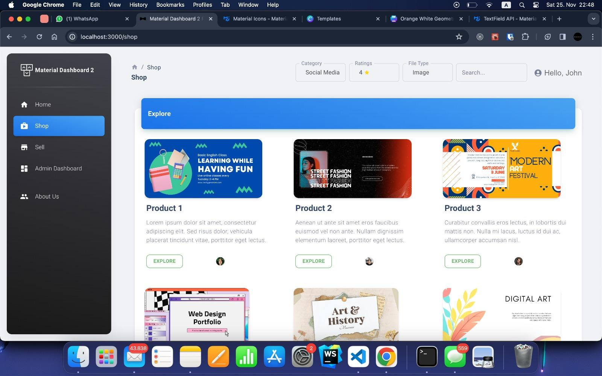

Product Details Page:

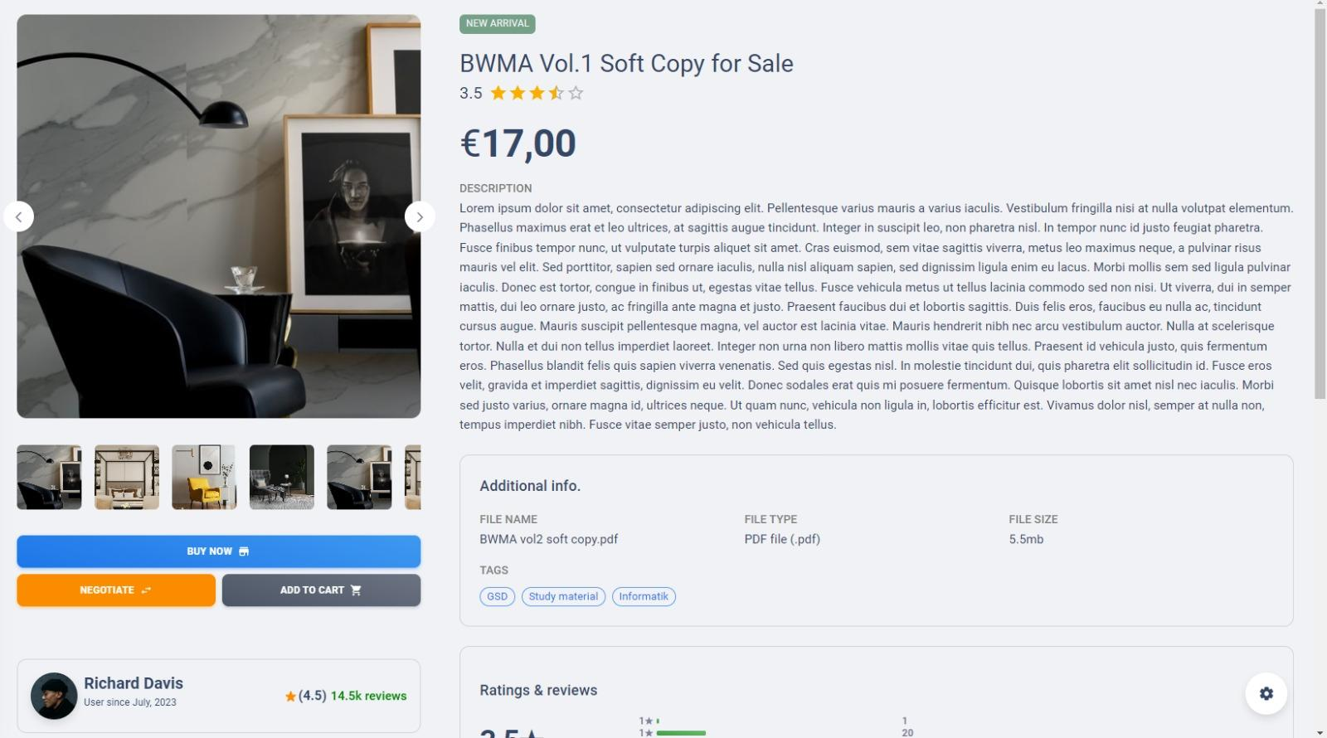

Message Page:

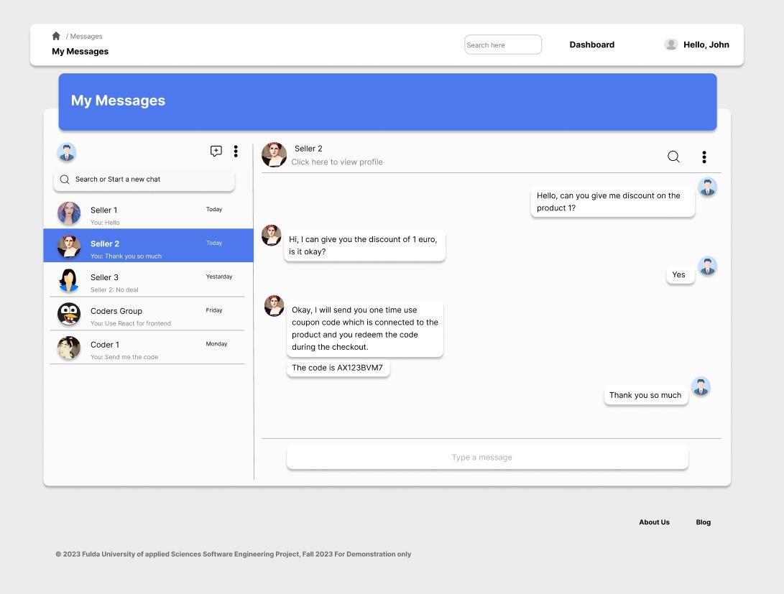

**4. High Level Architecture, Database Organization**

**DB organization:**

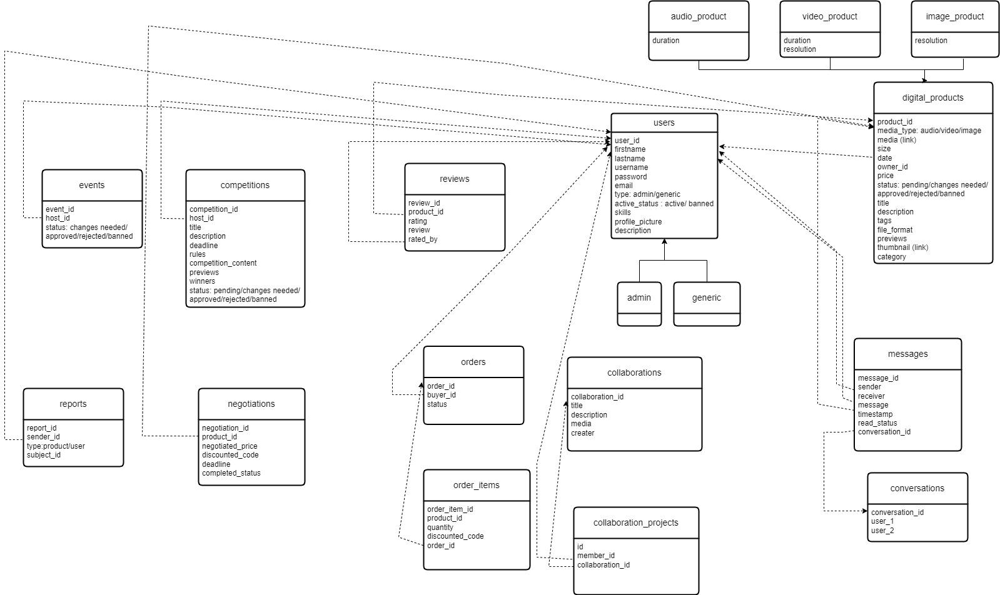

The following details provide additional information to supplement the presented ER diagram:

* In **digital_products** table, ‘*media_type’* will be taken from a separate table where each media type (audio,video,image etc) has a media type id. Instead of repeating the media type string, this id will be used in this table. Same approach can be used for ‘*status’* and ‘*category’* columns.
* In **users** table, for modeling purposes, we have drawn two tables as ‘admin’ and ‘generic’. However, when it comes to implementation, ‘*type’* will be retrieved from a separate table where each user type (admin/generic) is saved with a user type id.
* In **reports** table, ‘*subject_id’* can be either *‘product_id’* or the *‘user_id’* depending on the *type*.
* In **messages** table, each message is linked with a ‘*conversation_id’* from **conversations** table so that we can easily get all the conversation messages occurred between two users.
* In **order_items** table, each order item is linked with an order from the **orders** table with the ‘*order_id’*. Whenever an item is added to the order in the shopping cart, order item will be added and whenever it is removed, it is deleted from the **order_items** table. When the order is completed, there will no longer be new order items with the same ‘*order_id’*.

**Media storage:**

We will be using **Azure Blob Storage** to store the high-resolution digital media and also the previews of them uploaded by the users.

**Search/filter architecture and implementation:**

When a potential buyer searches for a product, we would leverage from MySQL FULLTEXT search in order to give better user experience, larger set of matches and efficient response. For that, FULLTEXT indexing would be created on ‘*product title*’, ‘*description’* and ‘*tags’* fields. When a search is requested, matches would be found using all three fields and the union of all three would be the final result. This decision was chosen instead of a simple “%LIKE” query because in LIKE queries, the text would have to be an exact match for the searched phrase and a single letter mistake could result 0 matches. In FULLTEXT search, the matches do not have to be exact. Same way, FULLTEXT indexing would be created on *‘competition_title*’ and *‘description’* on the competitions table.

**Own APIs:**

Only the major APIs are listed below.

POST - /user —-> create user

GET - /user —--> details in the user table

GET - /user/products —-> products where user id = user_id

POST - /products —> upload a product by user

GET - /products/product_id —-> click specific product

GET - /products/?queryterms —-> search by buyer,search in product.name , product.description or tags

POST - /products/product_id/user_id —> buy a product

POST - /messages —-> send message

GET - /messages/conversation_id —> load conversation

POST - /events —-> create event

GET - /events —--> details in the events table

POST - /competitions —-> create competition

GET - /competitions —--> details in the competitions table

POST - /reports —-> create report

GET - /reports —--> details in the report table

POST - /reviews —-> create review

GET - /reviews —--> details in the reviews table

POST - /collaborations —-> create collaboration

GET - /collaborations —--> details in the collaborations table

POST - /orders —-> create order

GET - /orders —--> details in the orders table

DELETE - /order_item_id —---> delete order item from order_items table when an item is removed from the shopping cart

**SW tools and frameworks:**

Frontend Template:

* Material UI

Project Management and Collaboration:

* Jira

**5. High Level UML Diagrams**

**Class Diagram:**

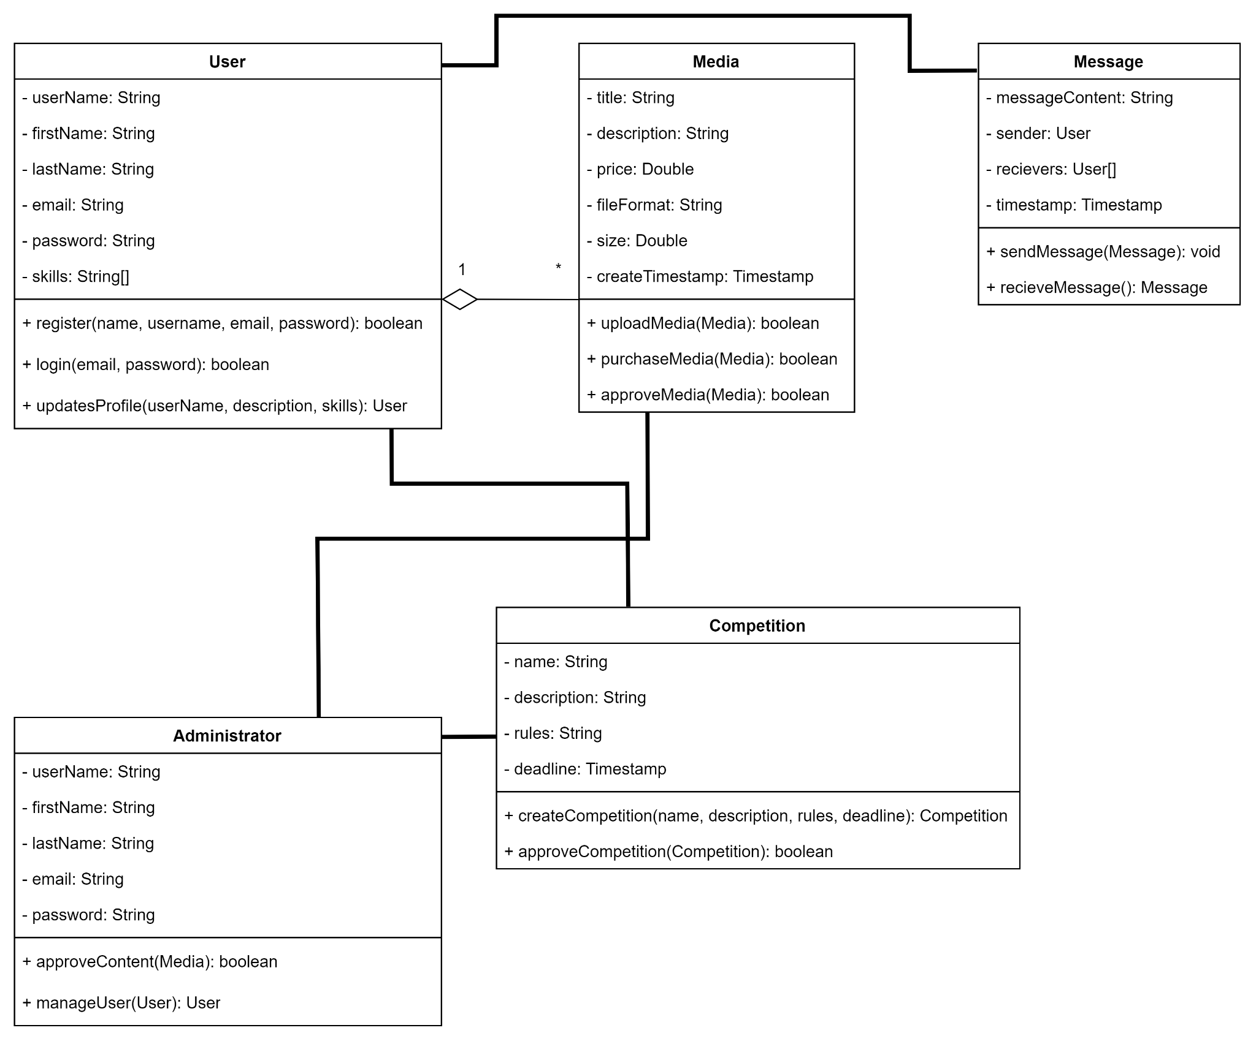

The Class Diagram encapsulates the foundational classes and their respective attributes and methods for the ArtSync Fulda project. It illustrates the core functionality of user management, media management, collaboration, administrator functions, messaging, and competition hosting. The User class contains essential attributes such as username, name, email, password, skills, and associated methods like register, updateProfile, and login. Similarly, the Media class encompasses attributes like title, description, price, along with methods such as uploadMedia, approveMedia, and purchaseMedia. Additionally, the diagram portrays the functionalities of the Administrator class responsible for approveContent and manageUsers, along with the Competition class handling createCompetition and approveCompetition and the Message class responsible for handling messages between users by providing sendMessage and recieveMessage functionalities. This representation provides a clear overview of the essential classes and their interactions within the ArtSync Fulda system, laying the groundwork for the implementation of its key functionalities.

**Component Diagram:**

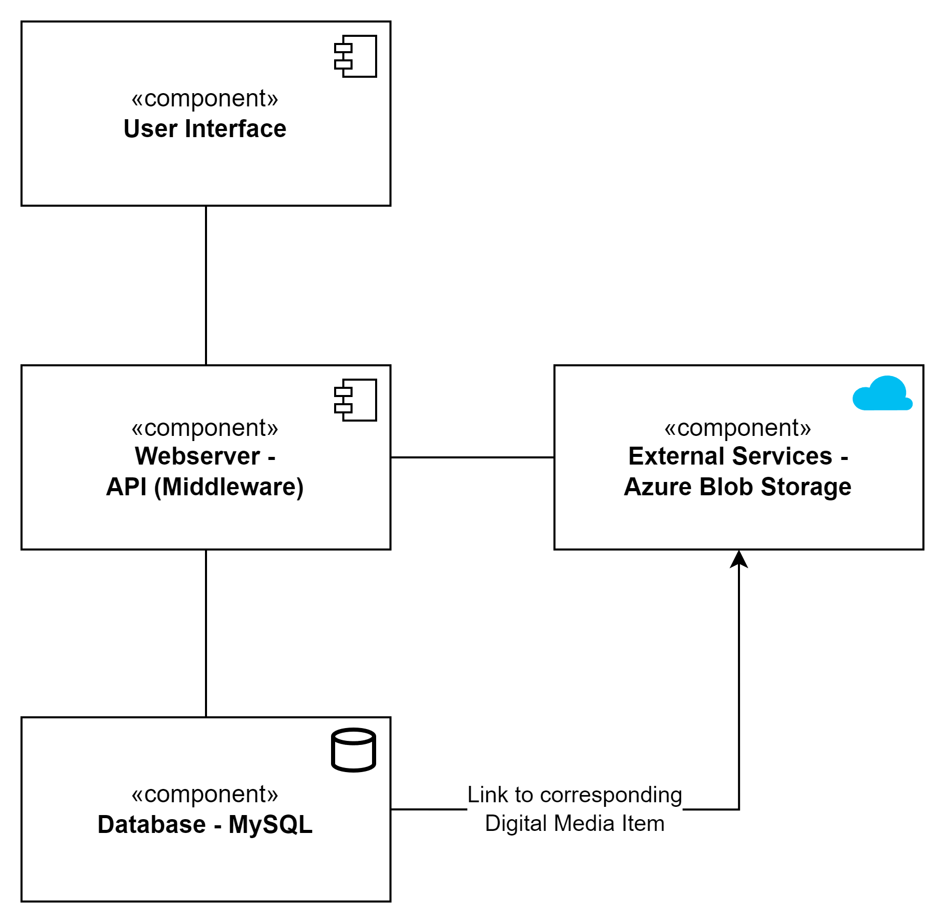

The system architecture illustrated in the component diagram depicts a cohesive structure comprising several interconnected components. At the top, the "User Interface" component serves as the entry point, channeling interactions to the "Webserver - API (Middleware)" component.

The “Webserver - API (Middleware)” component acts as the intermediary, connecting directly to the "Database - MySQL," where crucial data is stored and managed. Additionally, the "Webserver - API" component extends its connections to the "External Services - Azure Blob Storage", which provides seamless access and storage of the actual digital media items.

The “Database - MySQL” component is also connected to the “External Services - Azure Blob Storage” component because the Database component needs to connect to the corresponding digital media item in the Azure Blob Storage to easily retrieve and store digital media from and for users.

This setup facilitates a streamlined flow of information, allowing users to interact with the system through the user interface, while the interconnected components collaboratively manage, process, and store essential data and resources.

**Deployment Diagram:**

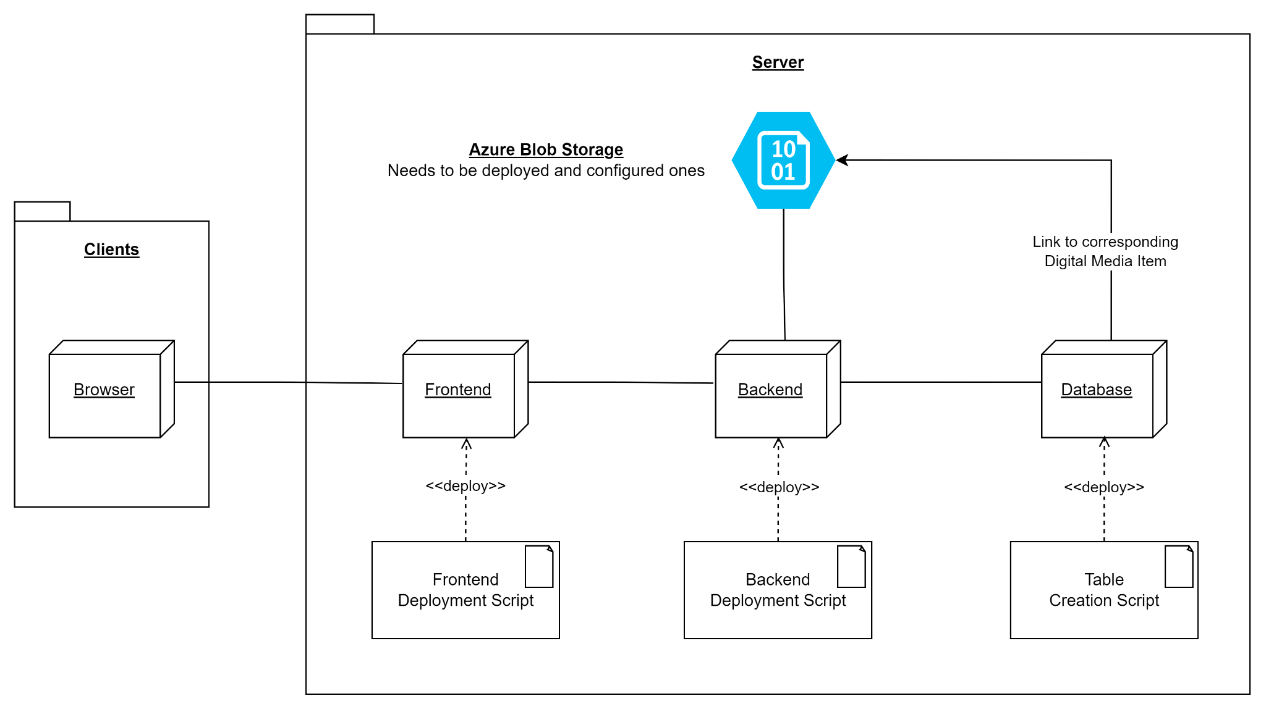

The Deployment Diagram illustrates the architecture of a system, showing the interaction between client and server nodes. On the left side we have our clients that use our service through browsers. On the right, we have our server package which includes the "Frontend", "Backend", and "Database" nodes. Deployment scripts are associated with each node, indicating the deployment process separated by each module. Connections show the flow: the browser connects to the frontend, which communicates with the backend. The backend interacts with both the database and an Azure Blob Storage node to store the data and the actual digital media items. The database also connects to the Azure Blob Storage node through a field in a database table that points to the corresponding digital media item in the Azure Blob Storage. Each node can be deployed independently and multiple times. Only the Azure Blob Storage needs to be deployed and configured once. This diagram visualizes the deployment sequence and the relationships between nodes within the system.

**6. Identify actual key risks for your project at this time**

#### **Skills Risks**

**1. Limited Proficiency in React, NodeJS and MySQL**

Risk: Some team members might lack sufficient expertise in React, NodeJS and MySQL, impacting the quality and efficiency of development.

Resolution Plan: Conduct specialized training through online courses and tutorials focused on React, NodeJS and MySQL based on member’s affinity and skill level in the technology. Pair team members with varying skill levels to facilitate knowledge sharing and skill transfer, especially between backend and frontend team members, so that each member understands how the other module works.

**2. Inadequate Deployment Skills**

Risk: Insufficient expertise in deploying applications to cloud servers like Azure, leading to deployment issues or suboptimal configuration.

Resolution Plan: Perform training or workshops specifically focused on deployments using Azure. Engage with Azure documentation and resources to build a robust understanding of deployment best practices. Implement trial deployments for hands-on practice and experimentation. Create a simple deployment script so any team member can easily deploy.

#### **Schedule Risks**

**1. Unrealistic Estimation of Development Time**

Risk: Overestimating team capacity might lead to missed deadlines and incomplete feature sets. Unrealistic time estimation for feature development and testing, potentially also causing delays in milestone completion.

Resolution Plan: Break down tasks into smaller, manageable units with clearly defined milestones. Regularly reassess progress against these milestones and adjust the schedule as needed. Implement Agile practices to adapt to changing requirements effectively.

**2. Conflict with Other Academic Obligations**

Risk: Overlapping project timelines with other academic courses or commitments might lead to reduced available time and focus on this project, potentially causing delays or compromised quality.

Resolution Plan: Conduct a comprehensive assessment of all team members' academic schedules and commitments for the semester. Collaboratively plan project tasks considering individual schedules to allocate realistic timelines. Prioritize crucial project milestones to avoid conflicts with high-demand periods from other courses.

#### **Technical Risks**

**1. Challenges with Messaging System**

Risk: Integrating and implementing the in-site messaging system might encounter unforeseen technical challenges.

Resolution Plan: To mitigate the challenges related to the in-site messaging system, our plan involves allocating additional time in the development schedule for thorough prototyping and testing. We'll leverage available online resources, documentation, and community forums to troubleshoot potential technical issues. By dedicating ample time for experimentation and trial runs, we aim to identify and resolve integration and implementation challenges.

**2. Issues with Storing different Digital Media**

Risk: Managing various types and sizes of digital media (images, videos, audio) could lead to inefficient storage structures, affecting performance and accessibility.

Resolution Plan: To address this, the team will implement a scalable and optimized storage solution. Utilizing cloud-based object storage services, such as Amazon S3 or Azure Blob Storage, allows efficient storage and retrieval of diverse media types. Implementing a tagging or categorization system based on media types, sizes, and metadata will further streamline storage and retrieval processes, ensuring efficient organization and accessibility for users. Regular monitoring and optimization of storage structures based on usage patterns will also be a priority to maintain performance and scalability.

#### **Teamwork Risks**

**1. Communication Breakdowns**

Risk: Miscommunication or lack of effective communication might impede progress and cause misunderstandings among team members.

Resolution Plan: Establish regular communication channels through weekly meetings, collaborative tools and open communication via Whatsapp. This might be a bigger problem during the semester break since team members do not meet in the Hochschule.

**2. Misaligned Expectations**

Risk: Varying interpretations of project goals and deliverables among team members might lead to misaligned efforts.

Resolution Plan: Clearly define project objectives, scope, and individual responsibilities. Conduct regular check-ins to ensure everyone understands and aligns with the project's vision and goals. Ensure each team member reads Milestones and all previous Milestone documents produced by the team.

#### **Legal/Content Risks**

**1. Copyright Violation Due to User-Uploaded Content**

Risk: Users might upload copyrighted content unknowingly, leading to potential legal issues for the platform.

Resolution Plan: Implement stringent content moderation and validation processes. Utilize automated tools or algorithms to flag potential copyright violations. Educate administrators about copyright policies and provide clear guidelines for content submission.

**7. Project Management**

As we progress into Milestone 2 and beyond, our project management strategy focuses on enhancing team efficiency and ensuring a streamlined workflow between the frontend and backend teams. Acknowledging the importance of independence and collaboration, we aim to establish clearer interfaces while fostering autonomy within each team.

#### **Task Assignment and Ownership**

Our approach revolves around meticulous task assignment, emphasizing clear identification of responsible individuals and their deadlines for each task. We're adhering closely to the principles of project management, ensuring that every task is accounted for and allocated appropriately.

#### **Coordination and Collaboration Tools**

To facilitate effective task management and team coordination, we've adopted Jira, an intuitive project management tool. Jira provides a unified dashboard view, allowing us to comprehensively oversee and track the status of all tasks. It offers a user-friendly interface that aids in assigning tasks, setting deadlines, and monitoring progress. Each member can create tasks, assign tasks to themselves or others according to their expertise, and move their tickets to the appropriate status.

#### **Milestone 2 and Beyond**

Moving into Milestone 2, our plan entails creating distinct tags for the frontend and backend teams to operate more autonomously on the Jira board. However, we are concurrently establishing common interfaces to ensure seamless integration between our modules. This approach aims to bolster efficiency and productivity while maintaining cohesion across the development process.

#### **Future Tasks and Tools Utilization**

As we progress beyond Milestone 2, our strategy involves leveraging Jira extensively for task management. Its collaborative features enable real-time updates and discussions, ensuring that every team member remains aligned with the project's objectives and deadlines. Additionally, we foresee utilizing other collaborative tools like GitHub for code management and version control, Tools for design collaboration and Google Docs to collaborate on Milestone documents, further optimizing our workflow.

In summary, our project management approach for Milestone 2 and the subsequent Milestones revolves around fostering independence within teams, ensuring meticulous task assignment, and employing tools like Jira for streamlined coordination and tracking. This strategy aims to enhance efficiency and maintain a clear roadmap for the successful execution of our project throughout the upcoming Milestones and development activities.